1. Praktikum 1

import java.util.Scanner;

public class prak1{

public static void main(String []args){

Scanner sc= new Scanner(System.in);

int [][]nilai=new int [2][3];

nilai[0][0]=12;

nilai[0][1]=14;

nilai[0][2]=34;

nilai[1][0]=30;

nilai[1][1]=21;

nilai[1][2]=67;

System.out.println(nilai[0][0]+" "+nilai[0][1]+" "+nilai[0][2]);

System.out.println(nilai[1][0]+" "+nilai[1][1]+" "+nilai[1][2]);

}

}

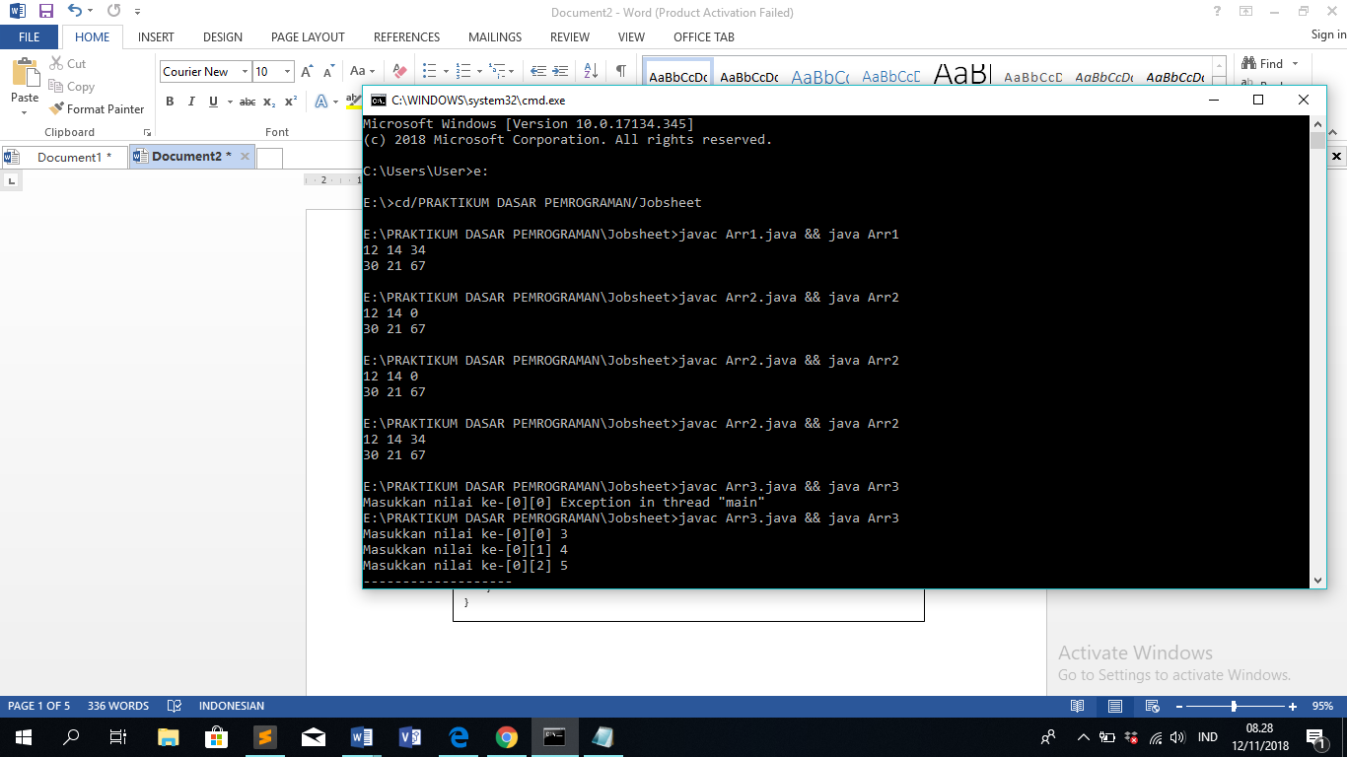

1. Praktikum 2

import java.util.Scanner;

public class prak2{

public static void main(String []args){

Scanner sc= new Scanner(System.in);

int[][]nilai=new int[2][3];

nilai[0][0]=12;

nilai[0][1]=14;

nilai[0][2]=34;

nilai[1][0]=30;

nilai[1][1]=21;

nilai[1][2]=67;

for(int i=0;i<2;i++){

for(int j=0;j<3;j++){

System.out.print(nilai[i][j]+" ");

}

System.out.println(" ");

}

}

}



1. Praktikum 3

import java.util.Scanner;

public class prak3{

public static void main(String []args){

Scanner input= new Scanner(System.in);

int[][]nilai=new int[2][3];

for(int i=0;i<2;i++){

for(int j=0;j<3;j++){

System.out.print("Masukkan nilai ke-["+i+"]["+j+"]");

nilai[i][j]=input.nextInt();

}

System.out.println("-------------------");

}

for(int i=0;i<2;i++){

for(int j=0;j<3;j++){

System.out.print(nilai[i][j]+" ");

}

System.out.println();

}

}

}

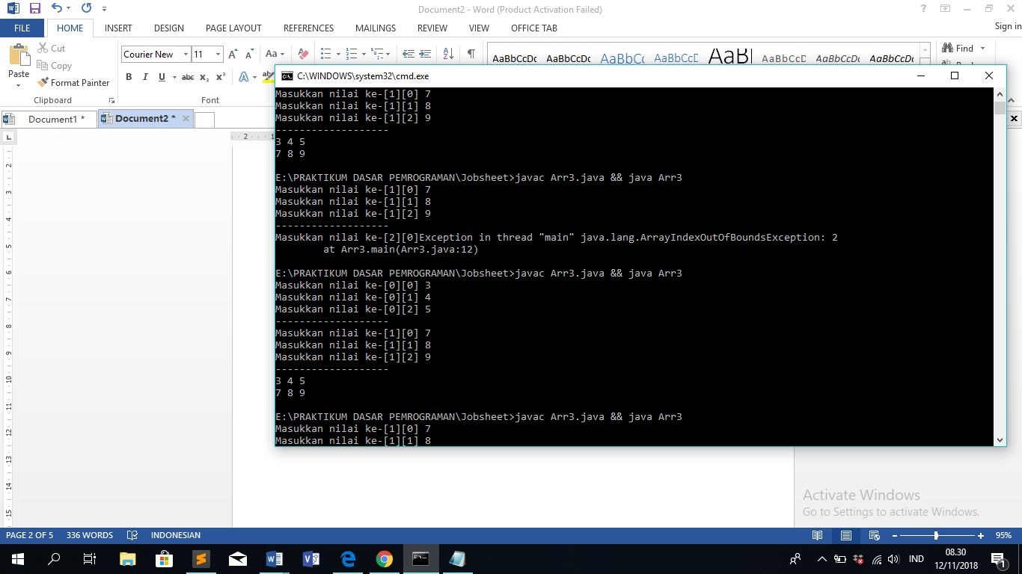

1. Praktikum 4

import java.util.Scanner;

public class Arr4{

public static void main(String []args){

Scanner input= new Scanner(System.in);

int barisA, kolomA;

System.out.print("Masukkan Size Baris Matriks A: ");

barisA=input.nextInt();

System.out.print("Masukkan Size Kolom Matriks A: ");

kolomA=input.nextInt();

int[][] MatrikA=new int[barisA][kolomA];

System.out.println("Input Elemen Matriks A: ");

for(int i=0;i<barisA;i++){

for(int j=0;j<kolomA;j++){

System.out.print("Matriks A[" +i+ "][" +j+ "]" + ":");

MatrikA[i][j]=input.nextInt();

}

System.out.println();

}

System.out.println("Hasil output matriknya adalah: ");

for(int i=0;i<barisA;i++){

for(int j=0;j<kolomA;j++){

System.out.print(MatrikA[i][j]+" ");

}

System.out.println();

}

}

}

